WanderPlan AI — User Guide: How the Architecture Supports Your Vacation Planning
Introduction
WanderPlan AI is a smart travel planning platform powered by a team of AI agents. This guide explains, in simple terms, how the system works behind the scenes when a couple uses the app to plan their vacation. The included diagram visually maps out the journey of your requests and how different parts of the system collaborate to deliver a personalized travel plan.

1. The User Journey: A Couple Plans Their Vacation
Step 1: Start with the App
- Both users (the couple) open the WanderPlan AI web or mobile app and enter their vacation preferences (e.g., “We want to visit Japan in April”).
Step 2: Secure Entry via API Gateway
- The app sends their requests to the API Gateway (Kong or Traefik), which checks security and routes the requests to the Orchestrator agent.
Step 3: Orchestrator Takes Charge
- The Orchestrator agent understands the intent (e.g., planning a trip), manages the planning process, and coordinates the next steps.
Step 4: Collaboration via Kafka Event Bus
- The Orchestrator sends tasks to specialist agents (like Bucket List, Timing, Interest, Flights, Hotels, etc.) using Kafka, a messaging system that ensures reliable communication.
Step 5: Specialist Agents Do Their Jobs
- Each agent works on its part of the plan (e.g., finding flights, suggesting hotels, checking weather, merging preferences for the couple).
- The Group Coordinator agent helps merge both users’ preferences for a seamless group experience.
Step 6: Shared State in Redis
- All agents read and update the shared trip plan in Redis, a fast, central memory store.
Note: The app never connects directly to Redis; only backend agents do.
Step 7: Data Layer Access
- Agents use specialized databases for storing and retrieving information:
  - PostgreSQL for users and bookings
  - MongoDB for trip plans
  - OpenSearch for searching points of interest
  - MinIO for files and media
  - Pinecone for semantic memory
Step 8: Monitoring and Safety
- Prometheus and Grafana monitor the system’s health.
- Automated backup scripts ensure your data is safe and recoverable.
Step 9: External Information
- Agents fetch real-time data from external APIs (flights, hotels, weather, maps, etc.) to enrich your plan.
Step 10: Results Delivered
- The Orchestrator collects all results, formats the response, and sends it back to the couple through the API Gateway and app.

2. Visual Diagram: How Your Vacation Plan Comes Together
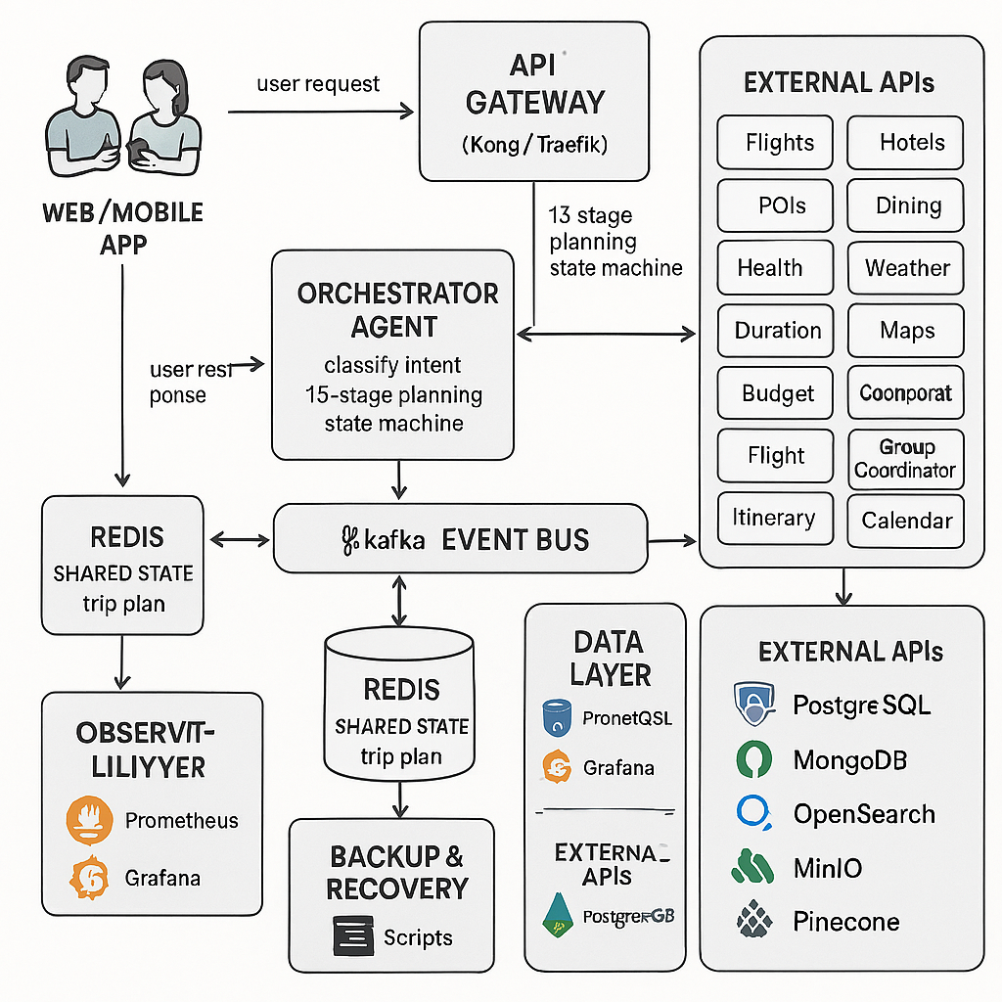Diagram Key Points:
- No direct connection between the app and Redis. All data access is through backend agents.
- Arrows show the flow:
Couple → API Gateway → Orchestrator → Kafka → Specialist Agents → Redis/Data Layer → Orchestrator → API Gateway → Couple
- Group coordination is highlighted, showing how both users’ preferences are merged for a personalized plan.

3. Why This Architecture?
- Security: Only backend services access sensitive data and business logic.
- Reliability: Messaging and data layers ensure nothing is lost, even if something fails temporarily.
- Scalability: The system can handle many users and complex plans by adding more agents.
- Flexibility: Open-source tools and modular design make it easy to update and expand.
- Collaboration: Designed for group planning, so couples and friends can plan together seamlessly.

4. Summary
WanderPlan AI’s architecture is like a team of expert assistants, each with a specific job, all working together to create your perfect trip. The system is secure, reliable, and designed for collaboration—so you can focus on dreaming up your next adventure.

